FINAL EXAMINATION PRACTICUM REPORT COMPUTER NETWORKING
Network Design and VLAN Implementation for a Three-Floor Building Using Cisco Packet Tracer


Lecturer:
Dimas Novian Aditia Syahputra, S. Tr. T., M. Tr. T.
Prepared by:
Name: Aisyah Currents
NIM (Student id): 25091397108
Class: International

UNIVERSITAS NEGERI SURABAYA
FACULTY OF VOCATION
INFORMATICS MANAGEMENT STUDY PROGRAM
YEAR 2025

TABLE OF CONTENTS

TABLE OF CONTENTS 1
CHAPTER I 2
INTRODUCTION 2
1.1. Background 2
1.2. Objectives 2
CHAPTER II 3
THEORETICAL BASIS 3
2.1. Computer Networks and VLAN 3
2.2. Case Study Scenarios 3
CHAPTER III 4
METHODOLOGY 4
3.1. Tools and Materials 4
3.2. Procedure 4
CHAPTER IV 7
CLOSING 7
4.1. Conclusion 7

CHAPTER I

INTRODUCTION

Background
The rapid development of information technology has increased the need for reliable and well-structured computer networks in multi-floor buildings. Different user groups such as public users, administrative staff, and IT personnel require different levels of network access to ensure efficiency and security. Without proper network segmentation, network traffic can become inefficient and sensitive resources such as servers may be accessed by unauthorized users.
One solution to address this problem is the implementation of a Virtual Local Area Network (VLAN). VLAN allows a physical network to be divided into multiple logical networks, improving network management, performance, and security. By using VLANs combined with inter-VLAN routing and access control mechanisms, network administrators can control communication between user groups based on their roles.
This practicum focuses on designing and implementing a VLAN-based network for a three-floor building using Cisco Packet Tracer. Each floor is assigned a different VLAN according to its function, and access to the server is restricted based on user roles to enhance network security.

Objectives
The objectives of this practicum are as follows:
- To implement VLAN segmentation based on user roles
- To configure inter-VLAN routing to enable communication between VLANs.
- To test and analyze network connectivity and access control results.

CHAPTER II

THEORETICAL BASIS

2.1. Computer Networks and VLAN
A computer network is a collection of interconnected devices that are able to communicate and share resources such as data, applications, and hardware. In a local area network (LAN), devices are usually connected within a limited area such as an office building or campus. As the number of users increases, network management and security become more challenging.
Virtual Local Area Network (VLAN) is a technology that allows a physical network to be divided into multiple logical networks. VLAN helps improve network performance by reducing broadcast traffic and enhances security by separating users based on their roles or departments. With VLAN, devices in different logical networks cannot communicate directly without proper routing.

2.2. Case Study Scenarios
This A three-floor building requires a structured and secure computer network to support different user roles on each floor. The building is used by public users, administrative staff, and an IT team that manages internal servers. Each group has different network access requirements, especially regarding access to sensitive server resources.
The first floor is designated for public users and is equipped with five personal computers. These users only require basic network connectivity and must not be allowed to access the server to maintain data security. The second floor is used by administrative staff and contains five personal computers. Admin users need broader network access, including permission to communicate with the server for administrative tasks. The third floor is reserved for the IT team and server infrastructure, consisting of four personal computers and one server. IT users require full access to manage and maintain the server.
To address these requirements, the network is designed using Virtual Local Area Network (VLAN) technology. Each floor is assigned a separate VLAN to segment network traffic based on user roles. VLAN 10 is assigned to public users on the first floor, VLAN 20 to administrative staff on the second floor, and VLAN 30 to the IT team and server on the third floor. Inter-VLAN routing is implemented to allow controlled communication between VLANs.
Access Control Lists (ACL) are applied to enforce role-based access control. Public users in VLAN 10 are restricted from accessing the server, while users in VLAN 20 and VLAN 30 are permitted to access server resources. The entire network is implemented and simulated using Cisco Packet Tracer, and the configuration results are documented as part of the final semester practicum report.

CHAPTER III

METHODOLOGY

3.1. Tools and Materials
The tools and materials used include:
- Laptop/PC with simulation software (Cisco Packet Tracer).
- Network device specifications (data sheet).
- Worksheet for manual design.

3.2. Procedure
Before starting the practicum, we need a clear process so the network design can be done step by step. This practicum helps students understand how to analyze needs, choose a topology, select devices, and create a network design using Cisco Packet Tracer. By following these steps:
- Needs Analysis
In In this practicum, a three-floor office building requires a structured and secure computer network to support different user roles on each floor. Each floor has specific functions and access requirements that must be managed properly to ensure network efficiency and data security.
The first floor is used by public users and is equipped with five personal computers. These users require basic network connectivity for general purposes, but they must not be allowed to access sensitive resources such as the internal server. The second floor is dedicated to administrative staff and contains five personal computers. Admin users require broader access to network resources, including communication with the server to support administrative operations. The third floor is reserved for the IT team and server infrastructure, consisting of four personal computers and one server. IT personnel require full access to the network to manage, maintain, and monitor the server.
To meet these requirements, the network must be able to separate users based on their roles while still allowing controlled communication between different network segments. Virtual Local Area Network (VLAN) technology is needed to logically divide the network according to each floor. In addition, inter-VLAN routing is required to enable communication between VLANs, and Access Control Lists (ACL) must be implemented to restrict server access for public users while allowing access for admin and IT users.

- Topology Selection
The network in this practicum uses a star topology because it provides high reliability, easy management, and good scalability for a multi-floor building. In a star topology, all end devices are connected to a central switch, which allows network administrators to easily monitor and manage network traffic.
The star topology is also suitable for VLAN-based networks because it supports clear user segmentation and efficient traffic control. By combining the star topology with VLAN and inter-VLAN routing, the network can separate public users, administrative staff, and IT personnel while still allowing controlled communication between them. Therefore, the star topology is chosen to support a structured, secure, and easily maintainable network design for this practicum.
- Network Design and User Segmentation
The Network Design
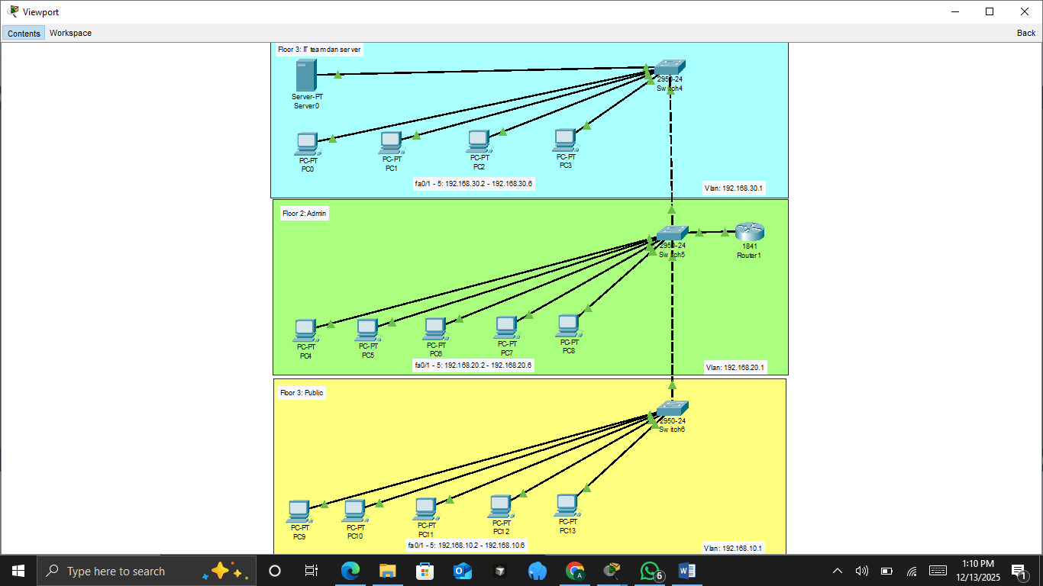
The network design in this practicum is implemented for a three-floor building using a centralized star topology. All end devices from each floor are connected to a central switch, which is directly connected to a router to enable inter-VLAN communication. This design allows efficient network management and clear separation of users based on their roles.
User segmentation is implemented using Virtual Local Area Network (VLAN) technology. Each floor is assigned a specific VLAN according to its function. The first floor is designated for public users and uses VLAN 10 with the IP network 192.168.10.0/24. This floor consists of five personal computers that only require basic network access and are restricted from accessing the server. The second floor is allocated for administrative staff and uses VLAN 20 with the IP network 192.168.20.0/24. This floor contains five personal computers that require access to internal network resources, including the server. The third floor is reserved for the IT team and server infrastructure and uses VLAN 30 with the IP network 192.168.30.0/24. This floor consists of four personal computers and one server that require full network access.
Inter-VLAN routing is configured on the router to allow communication between VLANs. To enforce security policies, Access Control Lists (ACL) are applied to restrict server access from VLAN 10 while allowing access from VLAN 20 and VLAN 30. This segmentation ensures that public users cannot access sensitive server resources, while administrative and IT users can perform their tasks efficiently.
The Ping Resuts from all VLAN to Router
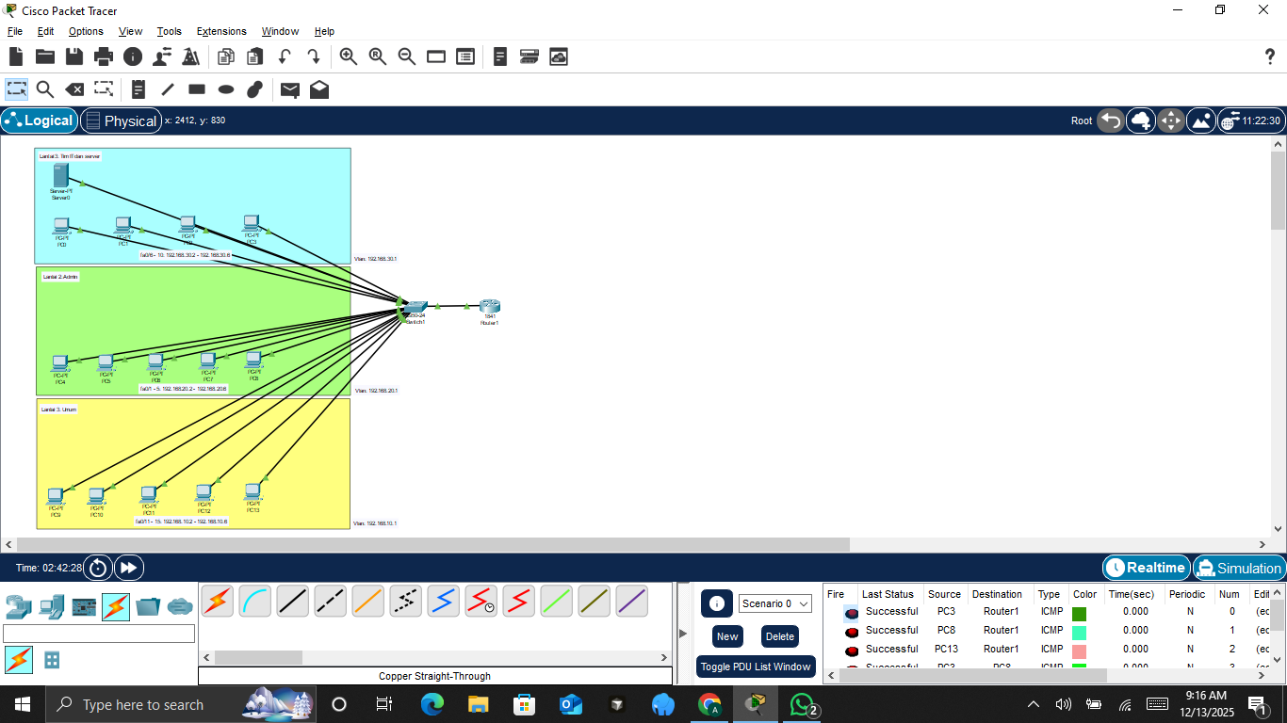
The Ping Results from all devices in VLAN 10 to Server
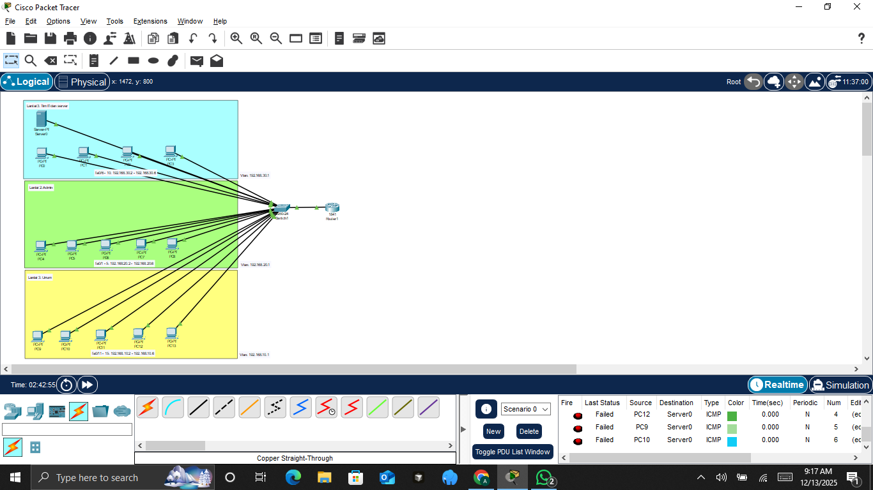
Overall, the network design and user segmentation provide a structured, secure, and manageable network that meets the requirements of the three-floor building and supports role-based access control.

CHAPTER IV

CLOSING

4.1. Conclusion
Based on the practicum results, the design and implementation of a VLAN-based network for a three-floor building were successfully completed using Cisco Packet Tracer. The network was structured using a star topology and segmented into three VLANs based on user roles, namely Public, Admin, and IT/Server. This segmentation helped improve network organization, efficiency, and security.
Inter-VLAN routing was successfully configured to allow controlled communication between different VLANs. Access Control Lists (ACL) were applied to restrict server access for public users while allowing administrative staff and IT personnel to access server resources. The testing results showed that all devices were able to communicate according to the defined access rules, and the server was protected from unauthorized access.
Overall, this practicum demonstrated the importance of proper network design, VLAN segmentation, and access control in managing a multi-floor building network. The implementation achieved the project objectives and provided a clear understanding of VLAN, inter-VLAN routing, and basic network security concepts.

